Sang Hwa Lee

INST 346

December 13, 2022

EC00: Founders of Computing

**1. Who you are highlighting**

Tim Berners-Lee

**2. When they lived**

( June 8, 1955 ~ )

**3. What they contributed to computing**

The person who created the World Wide Web (www). Tim Berners-Lee has taken several steps to create WWW. When he worked at CERN(European Organization for Nuclear Research) in 1980, he developed software for the convenience(the organization and management of information and hardware/software that each employee wants) of working. This is the ENQUIRE that forms the basis of w3. Since then, researchers who are far away from each other have proposed a hypertext information delivery method with the aim of effectively sharing various information about the study. Hypertext made it possible to cross various documents and get a variety of information through hyperlinks Since then, he created the first web server named CERN HTTPd, and at the same time, he developed Nexus, a browser that can create and read web pages. He shared W3's patents free of charge with many people to open and connect information.

**4. Why that contribution is important**

Most of what we do over the Internet is connected to www. Through it, we created an era where everyone in the world can create, store, and share information. Simply, to communicate, watch videos, buy products, to watch the news, all these things are connected to www. Websites like Google, which we commonly use, are available through these webs. Now, the World Wide Web is located as an integral part of people.

**5. Some pictures, preferably that include the person and their contribution**

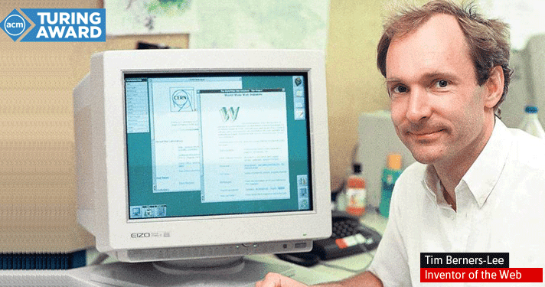

https://thehackernews.com/2017/04/tim-berners-lee-turing-award.html

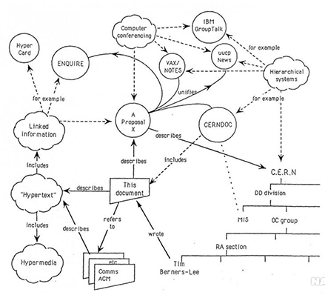

https://www.w3.org/History/1989/proposal.html

Works Cited

*Tim Berners-Lee, inventor of the web, wins $1 million Turing award 2016*. The Hacker News. (2017, April 5). Retrieved December 13, 2022, from https://thehackernews.com/2017/04/tim-berners-lee-turing-award.html

*The contributions of Tim Berners-Lee to our modern world*. Mental Itch. (2019, March 29). Retrieved December 13, 2022, from https://mentalitch.com/the-contributions-of-tim-berners-lee-to-our-modern-world/

*10 uses of World Wide Web & Importance of WWW and uses?* VPNBlade. (2022, December 13). Retrieved December 13, 2022, from https://www.vpnblade.com/10-uses-of-world-wide-web-and-importance/

Berners-Lee, T. (n.d.). *The next web*. Tim Berners-Lee: The next web | TED Talk. Retrieved December 13, 2022, from https://www.ted.com/talks/tim_berners_lee_the_next_web/transcript

*Uses & Importance of World Wide Web 2022 - what is WWW?* milliondeets. (2022, November 24). Retrieved December 13, 2022, from https://www.milliondeets.com/blog/uses-and-importance-of-world-wide-web/

*Information management: A proposal*. The original proposal of the WWW, HTMLized. (n.d.). Retrieved December 13, 2022, from https://www.w3.org/History/1989/proposal.html

Wikimedia Foundation. (2022, December 10). *Tim Berners-Lee*. Wikipedia. Retrieved December 13, 2022, from https://en.wikipedia.org/wiki/Tim_Berners-Lee